Replacing the WRN Setup Wizard with WRN Confirmation Tool

- Download the WRN-Config_Tool-Update.sh and wrn-configuration-tool.deb files to the root of USB drive. Please confirm that the 2 files are Located in the root of the USB drive- This is very Important
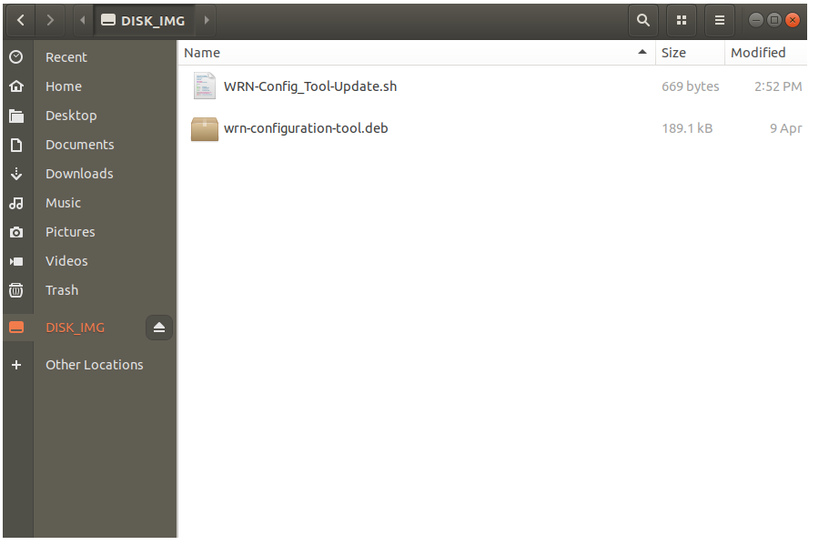

- From WRN UBUNTU, Open Terminal ( Ctrl+Alt+T)
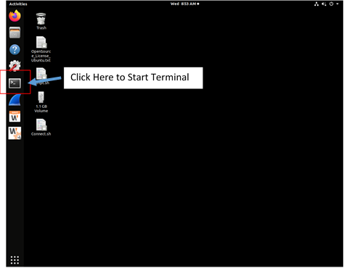

- Type the Following in Terminal
sudo –s
Enter the WRN WAVE Password and hit Enter
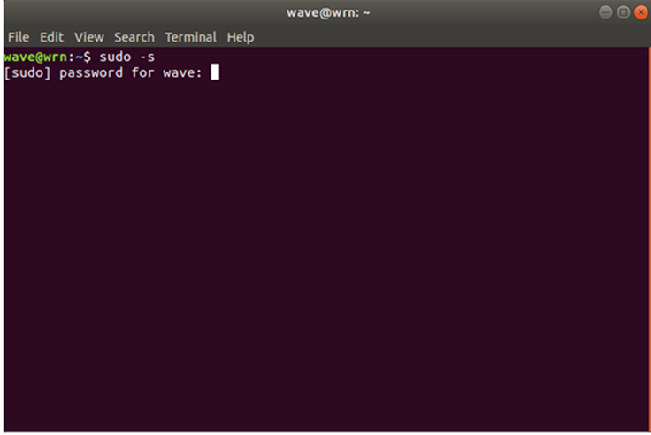

cd /media/wave/ & Hit tab key (This will insert the USB Drive Name)

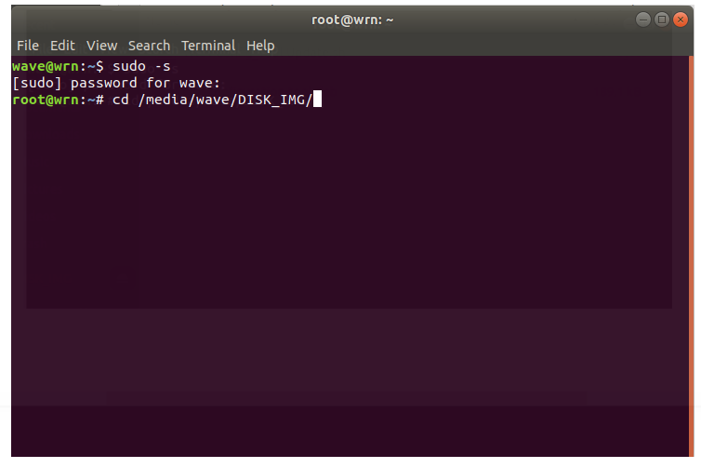
This is just an example of the USB drive name. Your USB drive name will be different

bash WRN-Config_Tool-Update.sh and hit Enter
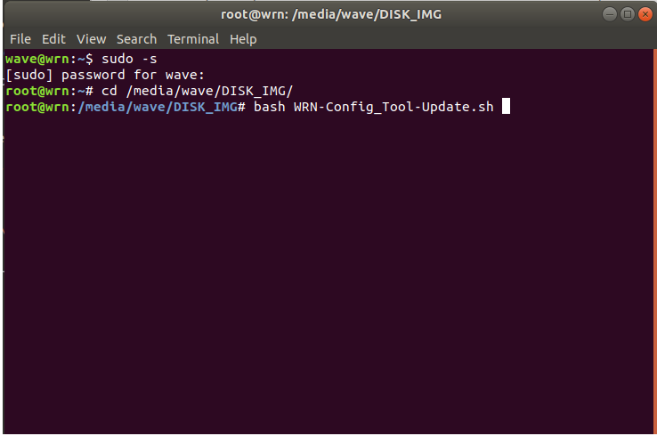

- Allow the script to run and observe for any failure messages if any. Once the Script is concluded, the WRN unit will be rebooted

