DS-1LN5EUSL5
U/UTP Cat5E LSZH 24AWG CPR Eca Cable

Feature and Function
- Stable electrical performance, compliant with ANSI/TIA-568.2-D, IEC61156, ISO/IEC11801.
- Compliant with RoHS 2.0.
- Sheath with strong mechanical properties, and high tensile and compressive strength, reducing damage during the project.
- Excellent performance in the Fluke 90-meter permanent link test while working continuously at 50°C high temperature.
- Excellent performance in the Fluke 100-meter channel test while being continuously loaded with 57 V/1 A DC power (PoE).
- Solid-Bare Copper conductor with less resistance, and better electrical properties and transmission performance.

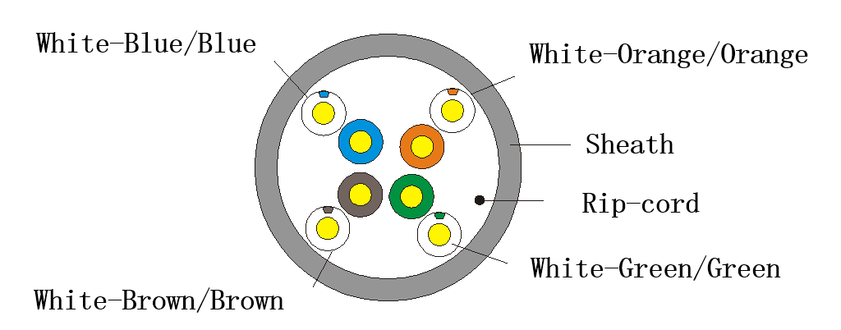

Specification
Model | DS-1LN5EUSL5
Category | Cat.5E
Sheath printing | HIKVISION NETWORK CABLE CAT5E U/UTP 24AWG LSZH CPR Eca VERIFIED TO ANSI/TIA-568.2-D ****m mm/dd/yyyy xx
Reference standard | ISO/IEC11801, ANSI/TIA-568.2-D, RoHS 2.0
Fire resistance | CPR Eca
Conductor | Material | Solid-Bare Copper (99.95%)
Conductor | Diameter | 0.50 ± 0.005 mm 24AWG
Insulation | Material | HDPE
Insulation | Diameter | 0.90 ± 0.05 mm
Sheath | Thickness | 0.50 ± 0.10 mm
Sheath | Diameter | 5.00 ± 0.40 mm
Sheath | Material | LSZH
Sheath | Color | White
Rip-cord | Yes
Separator | No
Sheath physical properties | Before aging | Tensile strength ≥ 10.0 Mpa  Elongation ≥ 125%
Sheath physical properties | Aging period | 100°C × 24h × 10d
Sheath physical properties | After aging | Tensile strength ≥ 8.0 Mpa  Elongation ≥ 100%
Sheath physical properties | Cold bend | -20 ± 2°C × 4h, 8 × cable O.D, no visible cracks
Electrical  Characteristics (20°C) | 1.0-100.0 MHz impedance | 100 ± 15 Ω
Electrical  Characteristics (20°C) | 1.0-100.0 MHz delay skew | ≤ 45 ns/100 m
Electrical  Characteristics (20°C) | DC resistance | ≤ 9.38 Ω/100 m
Electrical  Characteristics (20°C) | DC conductor resistance unbalance | ≤ 4.0%
Electrical  Characteristics (20°C) | Package dimension | 350 mm (W) × 350 mm (H) × 255 mm (D) (13.78" × 13.78" × 10.04")
Electrical  Characteristics (20°C) | Weight | 11 ± 1kg
Electrical  Characteristics (20°C) | Cable length | (305 ± 1.5) m
Electrical  Characteristics (20°C) | Ambient temperature | -20°C to 75°C (-4°F to 167°F)
Electrical  Characteristics (20°C) | Operating voltage | 57 V

Technical Performance (100 m)
Frequency (MHz) | ATT (20 ℃) ≤ (dB) | RL ≥(dB) | NEXT ≥(dB) | PS NEXT ≥(dB) | EL FEXT ≥(dB) | PS EL FEXT ≥(dB) | Phase delay ≤(ns)
1 | 2.0 | 20.0 | 65.3 | 62.3 | 63.8 | 60.8 | 570
4 | 4.1 | 23.0 | 56.3 | 53.3 | 51.8 | 48.8 | 552
8 | 5.8 | 24.5 | 51.8 | 48.8 | 45.7 | 42.7 | 547
10 | 6.5 | 25.0 | 50.3 | 47.3 | 43.8 | 40.8 | 545
16 | 8.2 | 25.0 | 47.2 | 44.4 | 39.7 | 36.7 | 543
20 | 9.3 | 25.0 | 45.8 | 42.8 | 37.8 | 34.8 | 542
25 | 10.4 | 24.3 | 44.3 | 41.3 | 35.8 | 32.8 | 541
31.25 | 11.7 | 23.6 | 42.9 | 39.9 | 33.9 | 30.9 | 540
62.5 | 17.0 | 21.5 | 38.4 | 35.4 | 27.9 | 24.9 | 539
100 | 22.0 | 20.1 | 35.3 | 32.3 | 23.8 | 20.8 | 538

Available Model
DS-1LN5EUSL5

