DS-1LN6USL3
U/UTP Cat6 LSZH 23AWG CPR Cca Cable

Feature and Function
- Stable electrical performance, compliant with ANSI/TIA-568.2-D, IEC61156, ISO/IEC11801.
- Compliant with RoHS 2.0.
- Sheath with strong mechanical properties, and high tensile and compressive strength, reducing damage during the project.
- Excellent performance in the Fluke 90-meter permanent link test while working continuously at 50°C high temperature.
- Excellent performance in the Fluke 100-meter channel test while being continuously loaded with 57 V/1 A DC power (PoE).
- Solid-Bare Copper conductor with less resistance, and better electrical properties and transmission performance.

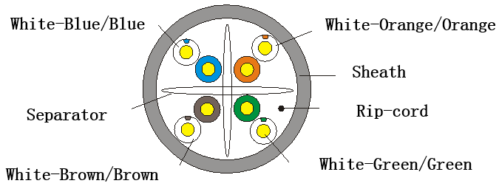

Specification
Model | DS-1LN6USL3
Category | Cat.6
Sheath printing | HIKVISION NETWORK CABLE CAT6 U/UTP 23AWG LSZH CPR Cca VERIFIED TO ANSI/TIA-568.2-D ****m mm/dd/yyyy xx
Reference standard | ISO/IEC11801, ANSI/TIA-568.2-D, RoHS 2.0
Fire resistance | CPR Cca s1a d0 a1
Conductor | Material | Solid-Bare Copper (99.95%)
Conductor | Diameter | 0.565± 0.005 mm 23AWG
Insulation | Material | HDPE
Insulation | Diameter | 0.98 ± 0.05 mm
Sheath | Thickness | 0.50 ± 0.05 mm
Sheath | Diameter | 6.20 ± 0.50 mm
Sheath | Material | LSZH
Sheath | Color | Blue
Rip-cord | Yes
Separator | Yes
Sheath physical properties | Before aging | Tensile strength ≥ 10.0 Mpa  Elongation ≥ 125%
Sheath physical properties | Aging period | 100°C × 24h × 10d
Sheath physical properties | After aging | Tensile strength ≥ 8.0 Mpa  Elongation ≥ 100%
Sheath physical properties | Cold bend | -20 ± 2°C × 4h, 8 × cable O.D, no visible cracks
Electrical  Characteristics (20°C) | 1.0-250.0 MHz impedance | 100 ± 15 Ω
Electrical  Characteristics (20°C) | 1.0-250.0 MHz delay skew | ≤ 45 ns/100 m
Electrical  Characteristics (20°C) | DC resistance | ≤ 9.38 Ω/100 m
Electrical  Characteristics (20°C) | DC conductor resistance unbalance | ≤ 4.0%
Electrical  Characteristics (20°C) | Package dimension | 400 mm (W) × 400 mm (H) × 255 mm (D) (15.75" × 15.75" × 10.04")
Electrical  Characteristics (20°C) | Weight | 15 ± 1kg
Electrical  Characteristics (20°C) | Cable length | (305 ± 1.5) m
Electrical  Characteristics (20°C) | Ambient temperature | -20°C to 75°C (-4°F to 167°F)
Electrical  Characteristics (20°C) | Operating voltage | 57 V

Technical Performance (100 m)
Frequency (MHz) | ATT (20 ℃) ≤ (dB) | RL ≥(dB) | NEXT ≥(dB) | PS NEXT ≥(dB) | EL FEXT ≥(dB) | PS EL FEXT ≥(dB) | Phase delay ≤(ns)
1 | 2.03 | 20.0 | 74.3 | 72.3 | 67.8 | 64.8 | 570
4 | 3.78 | 23.0 | 65.3 | 63.3 | 55.8 | 52.8 | 552
8 | 5.32 | 24.5 | 60.8 | 58.8 | 49.7 | 46.7 | 547
10 | 5.95 | 25.0 | 59.3 | 57.3 | 47.8 | 44.8 | 545
16 | 7.55 | 25.0 | 56.2 | 54.2 | 43.7 | 40.7 | 543
20 | 8.47 | 25.0 | 54.8 | 52.8 | 41.8 | 38.8 | 542
25 | 9.51 | 24.3 | 53.3 | 51.3 | 39.8 | 36.8 | 541
31.25 | 10.67 | 23.6 | 51.9 | 49.9 | 37.9 | 34.9 | 540
62.5 | 15.38 | 21.5 | 47.7 | 45.4 | 31.9 | 28.9 | 539
100 | 19.80 | 20.1 | 44.3 | 42.3 | 27.8 | 24.8 | 538
200 | 28.98 | 18.0 | 39.8 | 37.8 | 21.8 | 18.8 | 537
250 | 32.85 | 17.3 | 38.3 | 36.3 | 19.8 | 16.8 | 536

Available Model
DS-1LN6USL3

